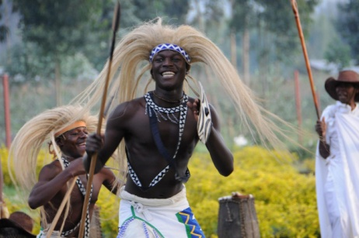
Welcome to our Next Destination: Rwanda
Rwanda has risen from the genocide and our Departure boys, Scott and Justin are taking us on a tour of Rwanda. For this destination your task is very simple. Answer the questions below
- List the different kinds of animals did you find in Rwanda. Which one intrigues you the most and why?

- Explain what happened at the former “church”? How many people were in there and how many people survived the atrocity?

- How did she survive?

- Could you or would you be so forgiving like the survivor? Explain!

- What are they making out of cow poop!

- What were the highlights from Napoleon island? What was there?

- What do the gorillas eat?

- If you could explain to someone what you saw/experienced in Rwanda in three sentences, what would you say? Use the landscape, animals, sights and experiences to guide you.

