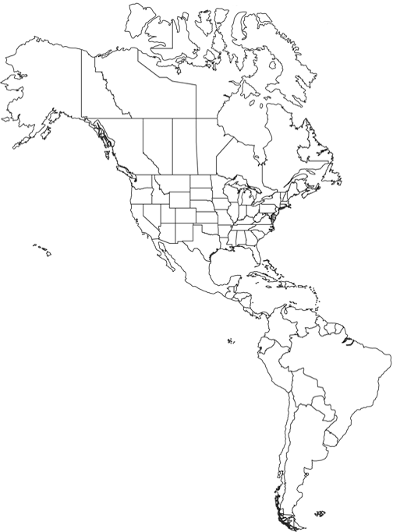

Preston High School Geography Department

**AMERICAS-WORLD ISSUES MAP**