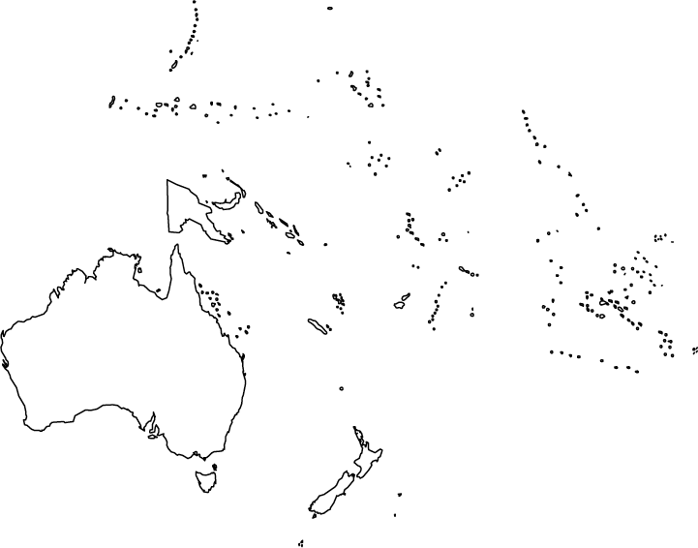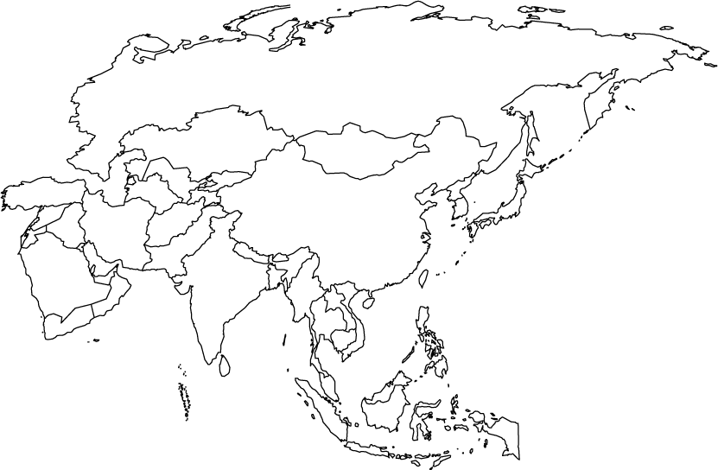

Preston High School Geography Department

**ASIA -WORLD ISSUES MAP**