PRESTON GEOGRAPHY DEPARTMENT
Travel and Tourism – Atlas Scavenger Hunt
We will be using Atlases extensively throughout this semester and we must be able to navigate through an atlas quickly and efficiently to complete assignments. For some of you, this will be review and for others, it may have been 4 years since you last looked through an atlas. This is good practice for future. For this assignment, we will be using the Oxford Atlas 9th Ed.
- What two types of maps are included in this atlas? _____________ ________________
- If you wanted to find world datasets, which pages would you look in? _____ -_____
- The world gazetteer begins on p. 207. Fill in the information for the following
Christchurch, ____ _____ _____ ______ _______
Country Page Number Alpha Numeric Grid Lat. Long
Now that you now know how to find information, use the Atlas the answer the following
- What is the only American state that starts with an “A” but that does not end with an “A”

- Hispaniola the 2nd largest island in the Caribbean – which two countries make up this island?

- Where was the highest temperature ever recorded? What was the temperature?

- What is the deepest point on earth? Where is it?
Fill in the table below using the information from the Atlas
Country | Capital
 | Brasilia
Costa Rica
 | Warsaw
Mongolia
Sri Lanka
Australia
Turkey
 | Vienna
Iceland
Indonesia
 | Tokyo
India

5. Of countries over 10 million, Bangladesh has the highest ______________ ____________ in the world with ______ ppl/sq. km
6. In 2006, the top tourist country in terms of arrivals was? ____________ – hint: use the table of contents?
7. Which country earns the most money from tourism in millions? ________________
8. What mode of transportation do the majority of people use to travel ______________
9. What are the worlds 2 busiest airports in terms of total passengers
1. ___________________ 84 846 639, 2. __________________ 77 028 134)
10. The Bay of Bengal and the Arabian Sea are separated by ________________.
Label the flags with the correct country –
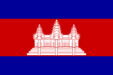
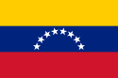
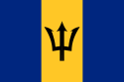
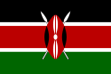
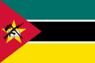
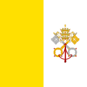
Bonus: Name all countries that have capital cities of the same name?

