Canadian Geography | CGC1DI

Population Pyramids

What are they?

What data do they use?

How are the created?

What can they tell us about an area’s population?

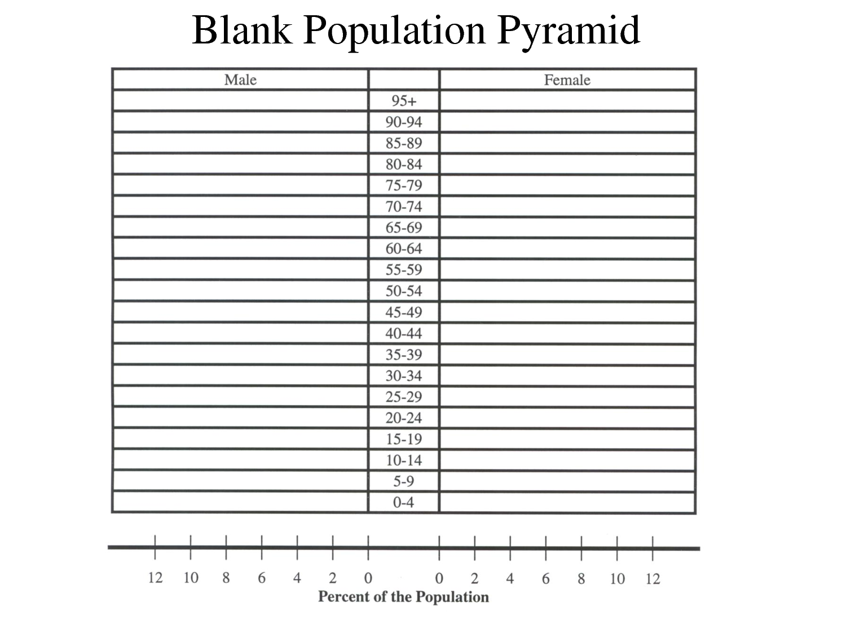

Types of Population Pyramids

Type 1: Rapid Growth
Reflects a population with:
- High birth rates and a high proportion of children
- High death rates, therefore people have a low life expectancy
(i.e. people don’t live long)
Examples
- Canadian – Nunavut (First Nations Reserves)
- Lesser Developed Countries (LDCs), Mali, Nepal

Type 2: Slow (Stable) Growth
Reflects a population with:
- Lower birth rates
- Lower death rates, therefore people have longer life expectancies
Examples
- Canadian – Northwest Territories
- Developing countries (BRIC and CUB), Brazil, Malaysia
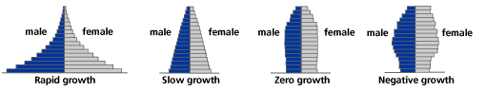

Type 3: Zero Growth
Reflects a population with:
- Equal numbers in all ages
Examples
- Canadian – all provinces except Maritimes
- More Developed Countries (MDCs), Australia, Japan

Type 4: Negative (Declining) Growth
Reflects a population with:
- A high number of elderly compared to younger age cohorts
- Very low birth rates
Examples
- Canadian – Maritimes (emigration)
- MDCs like Italy, Spain, Germany

