Preston High School Geography Department
CITY PLANNING QUESTIONS
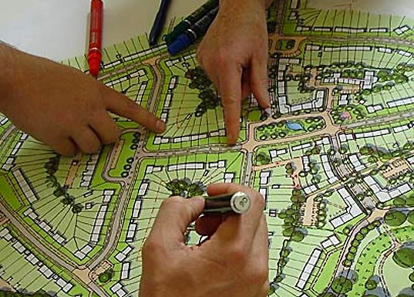
(Answer in complete sentences)

- What type of land use takes up the greatest area on your map? Why do you think this is so?

- What type of land use do you think should NOT be near factories? Why?

- How does transportation land use differ from other types of land use? (residential, commercial, industrial, recreational?)

- When you created your city map, explain what was the hardest thing for you to do?

- Place an ‘X’ on the house in your city in which you would like to live. Explain why.

- If you had to make one change in your city, what would it be and why?

