Demographic Homework
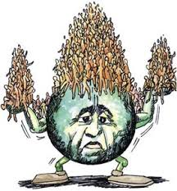

Show all your work!

Country Name: Mordor
Birth Rate: 27.3
Death Rate: 10.9
Immigration Rate: 2.7
Emigration Rate: 6.8
Population 64.8 million

- What is the rate of natural increase?

- What is the net migration rate?

- What is the TPG?

- What is the doubling time for this country?

- What type of country (refer to the demographic divide discussed) Why?

- What approximate stage is it in (refer to the Demographic Transition Model)

- What would be the actual population growth over the course of one year?

- What would be the new population at the end of the year?

