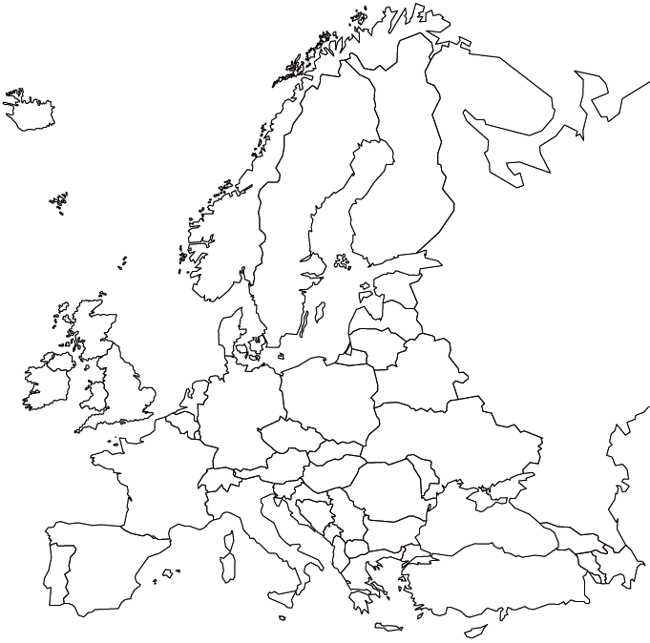

Preston High School Geography Department

**EUROPE-WORLD ISSUES MAP**