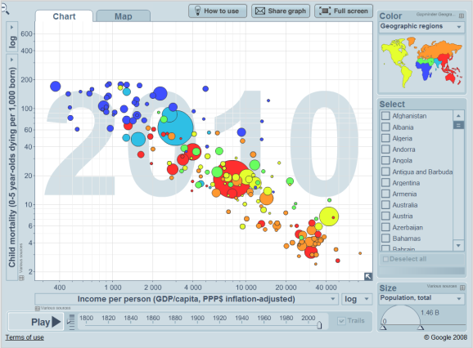
GAPMINDER LAB
(To be done in PAIRS)
Class Tutorial Presentation: Thursday, October 1
Purpose: Explore pairs of data, and look for relationships and reasons for the trends.
Steps:
Log in to Gapminder http://www.gapminder.org/
Navigate to Gapminder World and ‘play’ the data set loaded there for you
Click on: ‘200 years that changed the world’. View the video by Hans Rosling as he explains the data sets and analyses the trends and looks for reasons behind the data. Use this as a model for:
- How to use Gapminder in terms of buttons and features
- How to present information you have chosen using Gapminder
Once you have explored the program… load another set in which you believe there is a relationship and play it through. You may have to switch linear and log formats to your graph.
For help: Click on ‘How to Use’ Icon at the top of the graph for a list of features
Explore Your Data Set
Choose one in which you found a relationship between countries or groups of countries.
Highlight some key countries and/or groups of countries by continent (colour). Note that some countries in some categories do not appear because there is an absence of data, or the country does not exist yet give the timeframe you are looking at.
Class Tutorial Components: Due tomorrow… These are to be brief but insightful.
What criteria you chose and why. Explain what the data means? (see data box on lower left corner of Gapminder Graph or click on ‘data’ in the menu bar across the top of the page.)
Analysis: What relationships did you see? What did you discover? What are the possible reasons behind the data. Isolate individual countries of interest or regions. Explain trends in your data.
Use and manipulate the various features to highlight show, explain your data. What possible conclusions can you draw from your data.. ( google information on your relationship to see if you can find articles etc to support or look for conclusions)

