It’s your woodlot: How are you going to manage it?

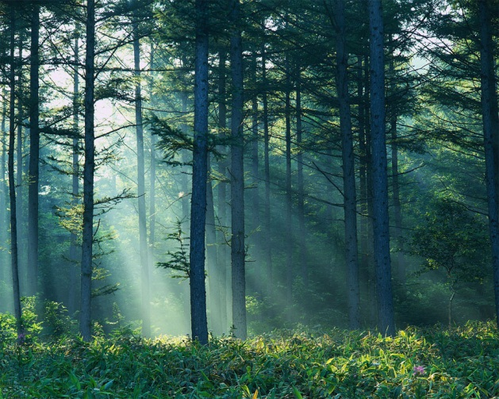
Background:
Landowners use woodlots for a variety for reasons in Southern Ontario. They provide home and food sources for birds and shelter for animals. Different people including hunters, recreationists, naturalists, foresters use the forest for a variety of things.
*Currently, privately owned forests are governed by municipal bylaws and owners must seek permits if trees are going to be cut on a large scale for harvest.
Task:
You, along with another classmate are business partners on a 10 hectare section of mixed - wood forest (deciduous and coniferous) in Southern Ontario. Your partnership has decided to harvest (cut and sell) the trees to generate income but want to maintain the environmental health of the forest ecosystem and its inhabitants. Within your forest, you have 100 trees of mixed species and it’s your decision as the owner, which trees you want to remove.
Particulars:
- 2 hills, a stream (brook trout and brown trout feeding and breeding grounds)
- All soils are sandy loam (excellent for trees)s
  - Snakes, turtles, salamanders, squirrels, coyotes, white-tailed deer, rabbits, hawks live in your woodlot
- You must place 100 trees using the below (include in a legend)
  - Hard maple 30% - …………………………………………….$1.50/board ft
  - White Pine 20% - ……………………………………………..$0.60/board ft
  - White Ash 20% - ……………………………………………..$0.80/board ft.
  - Black Cherry 20% - ……………………………………………$1.25/board ft.
  - Black Walnut 10%.............................................................$ 0.90/board ft.
Example : One Black Cherry tree = 200 ft x $.1.25 = $ 250)
All trees contain 200 board feet of lumber - they are all the same size
Mapping:
Map #1: You will be responsible for producing a coloured map of your woodlot including all the particulars from above with your trees placed. (5 marks)

Map #2: You will produce a 2nd map outlining the trees that have been removed for harvest (use a legend). You must include that same particulars as map 1, but include logging trails or roads that have been used to take out the logs and the loading areas for trucks. Remember, being that we are environmentally sensitive people, we need to take great care into where we place our roads and trees we cut but want to make the most money as possible! (10 marks)

Contour Profile: Using Map #2, you will construct a contour profile from points X to Y. Along that profile, label Mill River, roads, pathways, cut trees that intersect that line. (5 marks)

Response: You must discuss the following criteria under their respective headings in a typed response.

- What method of cutting did you use? Clear cutting, selective cutting or strip cutting? Explain why you chose the specific method. (Think economics and environmental sensitivity) (5 marks)

- Using Map 2, calculate the amount of wood harvested and how much money you have made from all the trees harvested. It’s your choice to cut as little or as much as you want, but you must show calculations along with the total revenue earned. (5 marks)

- Why did you select the specific trees to be harvested? Explain your reasoning of your road placement. Predict the overall health of your tree ecosystem and your wildlife ecosystem over the next 5, 10, 20 years. Do you think it will improve, remain stable or decline? Explain (10 marks)
/40

