Preston High School Geography Department
RELATIVE DATING LAB

PART I: LAWS AND PRINCIPLES OF GEOGLOGIC HISTORY

Using the Laws of Geologic History, determine the sequence of events as they occurred from oldest to youngest. Beside each rock layer, or event, put the letter of the law that you have base your decision on.
A. Law of Superposition B. Law of Cross- Cutting
C. Law of Inclusions D. Law of Unconformities

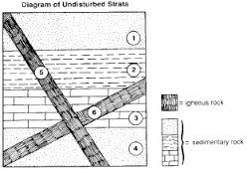
DIAGRAM 1.

LAYER | LAW

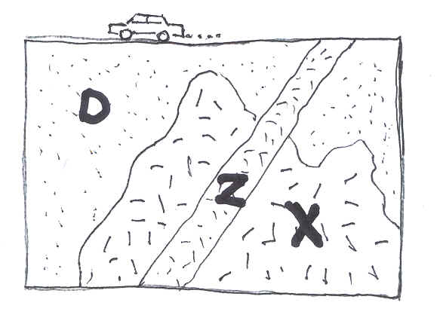
DIAGRAM 2.

LAYER | LAW

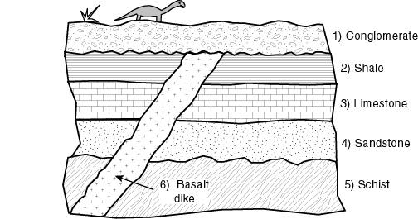

DIAGRAM 3.

LAYER | LAW

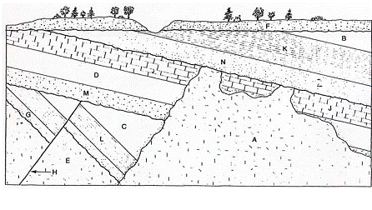

DIAGRAM 4.

LAYER | LAW

Fossil Index Species

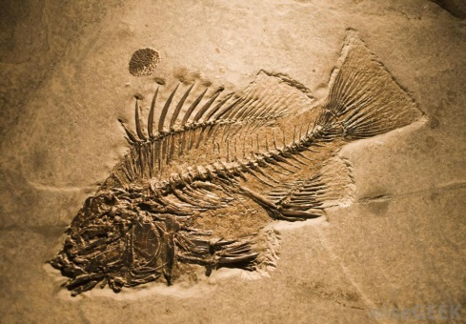
PART B: ‘WHO'S ON FIRST?’ USING INDEX FOSSILS
Objectives: When you complete this activity, you will be able to:
(1) sequence information using items which overlap specific sets; (2) relate sequencing to the Law of Superposition; (3) show how fossils can be used to give relative dates to rock layers.

Materials: two sets of sequence cards in random order (Set A: nonsense syllables; Set B: sketches of fossils), glue stick, scissors, paper
INTRODUCTION
Scientists have good evidence that the earth is very old, approximately four and one-half billion years old. Scientific measurements such as radiometric dating use the natural radioactivity of certain elements found in rocks to help determine their age. Scientists also use direct evidence from observations of the rock layers themselves to help determine the relative age of rock layers. Specific rock formations are indicative of a particular type of environment existing when the rock was being formed. For example, most limestones represent marine environments, whereas, sandstones with ripple marks might indicate a shoreline habitat or a riverbed.
The study and comparison of exposed rock layers or strata in various parts of the earth led scientists in the early 19th century to propose that the rock layers could be correlated from place to place. Locally, physical characteristics of rocks can be compared and correlated. On a larger scale, even between continents, fossil evidence can help in correlating rock layers. The Law of Superposition, which states that in an undisturbed horizontal sequence of rocks, the oldest rock layers will be on the bottom, with successively younger rocks on top of these, helps geologists correlate rock layers around the world. This also means that fossils found in the lowest levels in a sequence of layered rocks represent the oldest record of life there. By matching partial sequences, the truly oldest layers with fossils can be worked out.
By correlating fossils from various parts of the world, scientists are able to give relative ages to particular strata. This is called relative dating. Relative dating tells scientists if a rock layer is "older" or "younger" than another. This would also mean that fossils found in the deepest layer of rocks in an area would represent the oldest forms of life in that particular rock formation. In reading earth history, these layers would be "read" from bottom to top or oldest to most recent. If certain fossils are typically found only in a particular rock unit and are found in many places worldwide, they may be useful as index or guide fossils in determining the age of undated strata. By using this information from rock formations in various parts of the world and correlating the studies, scientists have been able to establish the geologic time scale. This relative time scale divides the vast amount of earth history into various sections based on geological events (sea encroachments, mountain-building, and depositional events), and notable biological events (appearance, relative abundance, or extinction of certain life forms).
Using Radioactive elements decay to determine fossil age.
The universe is full of naturally occurring radioactive elements. Radioactive atoms are inherently unstable; over time, radioactive “parent atoms” decay into stable “daughter atoms.”
When molten rock cools, forming what are called igneous rocks, radioactive atoms are trapped inside. Afterwards, they decay at a predictable rate. By measuring the quantity of unstable atoms left in a rock and comparing it to the quantity of stable daughter atoms in the rock, scientists can estimate the amount of time that has passed since that rock formed.
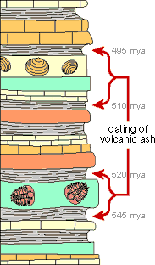
Bracketing the fossils
Fossils are generally found in sedimentary rock—not igneous rock. Sedimentary rocks can be dated using radioactive carbon, but because carbon decays relatively quickly, this only works for rocks younger than about 50 thousand years.
So in order to date most older fossils, scientists look for layers of igneous rock or volcanic ash above and below the fossil. Scientists date igneous rock using elements that are slow to decay, such as uranium and potassium. By dating these surrounding layers, they can figure out the youngest and oldest that the fossil might be; this is known as “bracketing” the age of the sedimentary layer in which the fossils occur

Procedure Set A: PRACTICE CARDS
1) Spread the cards with the nonsense syllables on the table and determine the correct sequence of the eight cards by comparing letters that are common to individual cards and, therefore, overlap. The first card in the sequence has "Card 1, Set A" in the lower left-hand corner and represents the bottom of the sequence. If the letters "T" and "C" represent fossils in the oldest rock layer, they are the oldest fossils, or the first fossils formed in the past for this sequence of rock layers.
2. Now, look for a card that has either a "T" or "C" written on it. Since this card has a common letter with the first card, it must go on top of the "TC" card. The fossils represented by the letters on this card are "younger" than the "T" or "C" fossils on the "TC" card which represents fossils in the oldest rock layer. Sequence the remaining cards by using the same process. When you finish, you should have a vertical stack of cards with the top card representing the youngest fossils of this rock sequence and the "TC" card at the bottom of the stack representing the oldest fossils. Glue them on to the front of your lab paper.
Interpretation Questions:
1) After you have arranged the cards in order, write your sequence of letters (using each letter only once) on a separate piece of paper. Starting with the top card, the letters should be in order from youngest to oldest.
2) How do you know that "X" is older than "M"?
3) Explain why "D" in the rock layer represented by DM is the same age as "M."
4) Explain why "D" in the rock layer represented by OXD is older than "D" in the rock layer represented by DM.
Interpretation Questions:
1) Using the letters printed in the lower left-hand corner of each card, write the sequence of letters from the youngest layer to the oldest layer (i.e., from the top of the vertical stack to the bottom). This will enable your teacher to quickly check whether you have the correct sequence.
2) Which fossil organisms could possibly be used as index fossils?
3) Name three organisms represented that probably could not be used as index fossils and explain why.
4) In what kinds of rocks might you find the fossils from this activity?
5) State the Law of Superposition and explain how this activity illustrates this law.
Set A (cut out and glue in sequence)
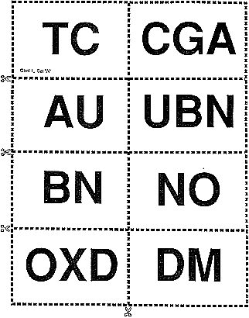

Procedure Set B: FOSSIL RECORD
1) Carefully examine the second set of cards which have sketches of fossils on them. Each card represents a particular rock layer with a collection of fossils that are found in that particular rock stratum. All of the fossils represented would be found in sedimentary rocks of marine origin. Figure 2A gives some background information on the individual fossils.
2) The oldest rock layer is marked with the letter "M" in the lower left-hand corner. The letters on the other cards have no significance to the sequencing procedure and should be ignored at this time. Find a rock layer that has at least one of the fossils you found in the oldest rock layer. This rock layer would be younger as indicated by the appearance of new fossils in the rock stratum. Keep in mind that extinction is forever. Once an organism disappears from the sequence it cannot reappear later. Use this information to sequence the cards in a vertical stack of fossils in rock strata.
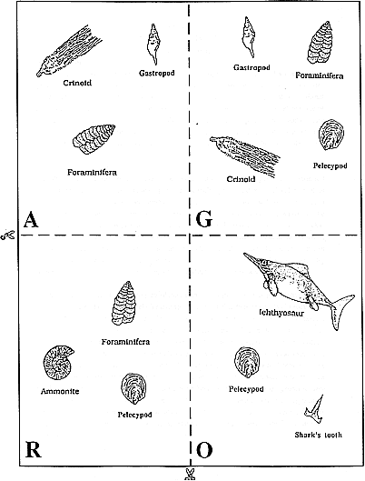
3) Cut them out and arrange them from oldest to youngest with the oldest layer on the bottom and the youngest on top. Glue to the back of the paper you used for Set A.
Set B: STRATA NUMBERS WITH FOSSIL RECORD CARDS (CUT OUT)

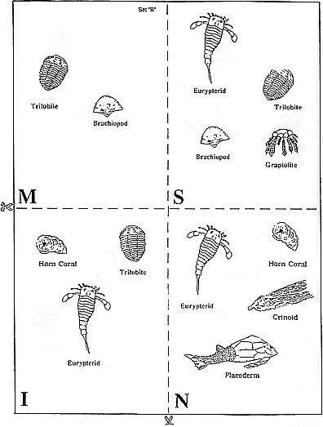

Figure 2-A. MARINE FOSSIL ORGANISMS
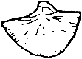 | 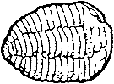 | 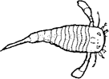
NAME: Brachiopod  PHYLUM: Brachiopoda  DESCRIPTION: "Lampshells"; exclusively marine organisms with soft bodies and bivalve shells; many living species | NAME: Trilobite  PHYLUM: Arthropoda  DESCRIPTION: Three-lobed body; burrowing, crawling, and swimming forms; extinct | NAME: Eurypterid  PHYLUM: Arthropoda  DESCRIPTION: Many were large (a few rare species were 5 feet in length); crawling and swimming forms; extinct
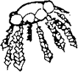 | 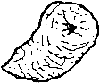
NAME: Graptolite  PHYLUM: Chordata  DESCRIPTION: Primitive form of chordate; floating form with branched stalks; extinct | NAME: Horn coral  PHYLUM: Coelenterata (Cnidaria)  DESCRIPTION: Jellyfish relative with stony (Cnidaria)(calcareous) exoskeleton found in reef environments; extinct | NAME: Crinoid  PHYLUM: Echinodermata  DESCRIPTION: Multibranched relative of starfish; lives attached to the ocean bottom; some living species ("sea lilies")
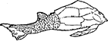 | 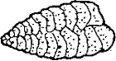 | 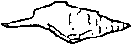
NAME: Placoderm  PHYLUM: Vertebrata  DESCRIPTION: Primitive armored fish; extinct | NAME: Foraminifera (microscopic type)  PHYLUM: Protozoa (Sarcodina)  DESCRIPTION: Shelled, amoeba-like organism | NAME: Gastropod  PHYLUM: Mollusca  DESCRIPTION: Snails and relatives; many living species
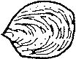 | 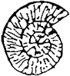 | 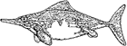
NAME: Pelecypod  PHYLUM: Mollusca  DESCRIPTION: Clams and oysters; many living species | NAME: Ammonite  PHYLUM: Mollusca  DESCRIPTION: Squid-like animal with coiled, chambered shell; related to modern-day Nautilus | NAME: Icthyosaur  PHYLUM: Vertebrata  DESCRIPTION: Carnivore; air-breathing aquatic animal; extinct
 | 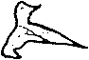
NAME: Shark's tooth
PHYLUM: Vertebrata
DESCRIPTION: Cartilage fish; many living species

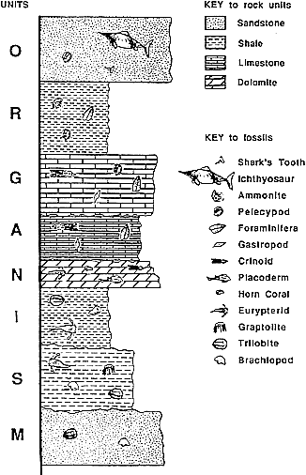
SEQUENCE FOR SET B

