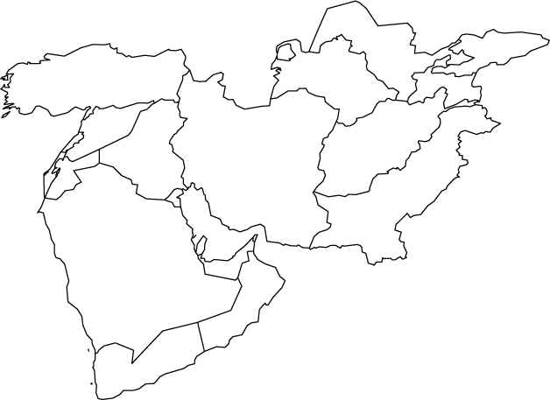

Preston High School Geography Department

**MIDDLE EAST – WORLD ISSUES MAP**