National Park Profile – Part 1 of CGC 1PI Summative Assignment

NAME: ________________________________

DUE DATE: __________________

Part A - INSTRUCTIONS

- Select one of Canada’s 40 National Parks/Wildlife Reserves and complete a booklet communicating your knowledge of the park.

National Park I am researching is: _____________________________

- Complete the TITLE PAGE worksheet for your Park, including
- Park Name
- Park Logo (5 marks)
- Pictures Representing different aspects of the Park (3 marks)

- Complete the LOCATION worksheet for your Park, including –
- Location indicated on Large Scale Map (3 marks)
- Location indicated on Small Scale Map (3 marks)

- Complete the PLACE worksheet for your Park, including –
- Absolute Location (2 marks)
- Relative Location (2 marks)
- Vegetation Description and Characteristics (2 marks)
- Accessibility of Park (how do you get there?) (2 marks)
- Types of Wildlife (3 marks)
- Prominent Landform (3 marks)
- Park’s Uniqueness (3 marks)

- Complete an INTERACTION worksheet for your Park, including –
- Reasons for Becoming a Park (3 marks)
- Historical Development (3 marks)
- Role of the Park Today (3 marks)
- Park Services (3 marks)
- Threats to the Park (3 marks)
/46

Part B – Park Infographic

For the research used in Part A, you will produce an infographic. An infographic is a visual illustration that uses images, photos, statistics and text to show information that your researched from Part A
- Go to this link - http://www.easel.ly/
- You will need to create an account that will let you save your infographic on the web.
- Your infographic will give a visual portrayal of what your park has to offer. You can be creative as you want!

Infographic Marking Scheme

Incorporates key information from National Park research
1 2 3 4 5

Information is accurate and arranged in an appropriate manor
1 2 3 4 5

Infographic is informative, attractive and creative using text and photos
1 2 3 4 5

Infographic is professionally presented and free of spelling/grammar errors
1 2 3 4 5

/20

Total /66
National Parks
of Canada
Three photos/drawings representing the park

Your logo for the park

National Park Name:

Location

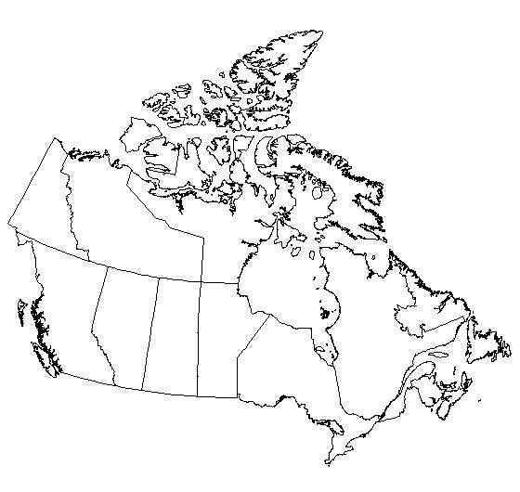
Locate the National Park and the on the Map of Canada.
Map of the National Park &
size of the National Park in km²

Location of the park on its provincial/territorial map

Place

Absolute Location
(latitude and Longitude)

Relative Location
(explain using n, w, s, e)

Vegetation
(examples & characteristics)

Accessibility
(how do you get there?)

Types of Wildlife

Aspects that make the Park unique

Prominent Landforms

Threats to the park

Park Services (what can you do there? What does the park offer?)

Role of the park today (what is it preserving)

Historical development (expansion, upgrades, etc.)

Reasons for creation of Park (when it was created and why)

