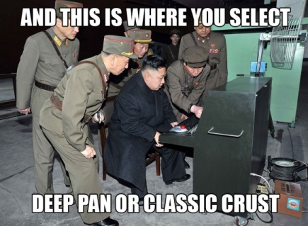
North Korea – The Musical

For westerners (us) not a lot is known about The Democratic Republic of North Korea. Most people know there are stringent rules for entering and leaving the country and it’s a political stance is a dictatorship run by Kim John Un. Lets check it out.

- What are 3 differences from the North Korean high school to Preston? Be specific

- Visitors to North Korea are to expect what from local residents?_________________

- What warfare product was used more in Korea than any other country during the Korean War?_______________________

- Why were the North Korean’s so proud to show off their water bottle factory?

- What do visitors have to do before they enter the co – operative farm?

- Why is it important to have the shovel and straw map in a glass case at the Co operative farm?

- How many people live on the farm
- What did Scott think was odd about their visit to the farm?

- What are three things did you think were most odd/different about the DPRK Amusement than to North American amusement parks?

- How deep into the ground is the subway in Pyongyang? Why did the Koreans design it this way?

- What names did they give the metro stops? What was the reasoning behind the names?

- What is significant about the May Day Stadium?

- What was your highlight of visiting DPRK

