**OVER CANADA**

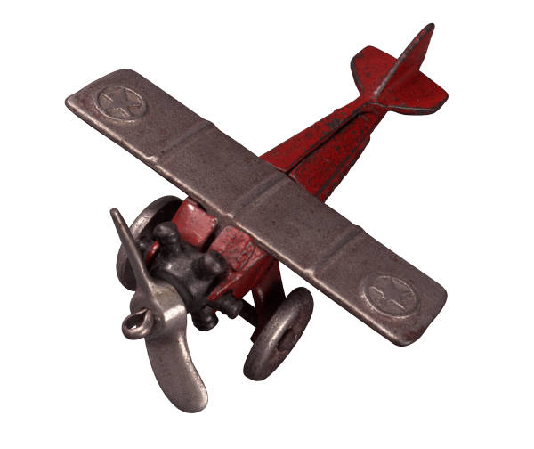

*For each region of Canada shown complete the*

*following observations*.

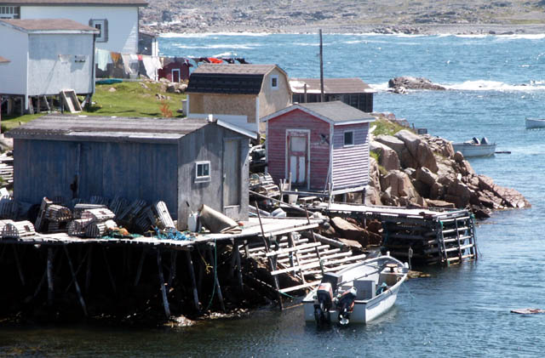

**REGION 1: __________________________________**

(name)

Provinces or Territories:

Landforms and Vegetation **(describe the land and plants)**

Human Activities **(jobs, culture, music, recreation, major landmarks)**

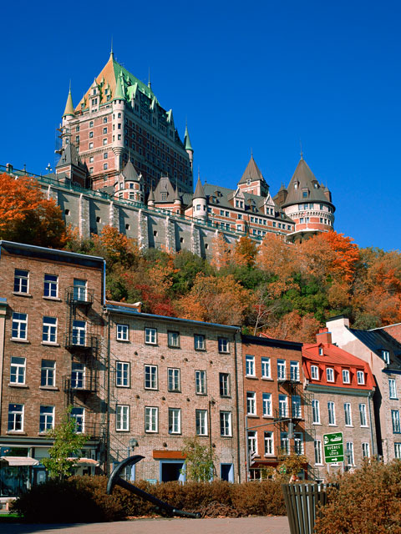

**REGION 2: __________________________________**

**(name)**

Provinces or Territories:

Landforms and Vegetation

Human Activities

**REGION 3: __________________________________**

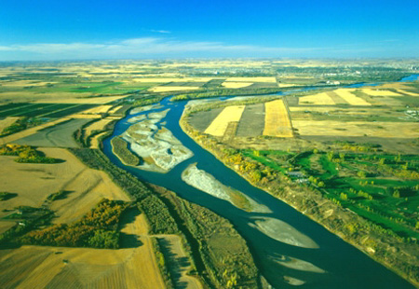

**(name)**

Provinces or Territories:

Landforms and Vegetation

Human Activities

**REGION 4: __________________________________**

(name)

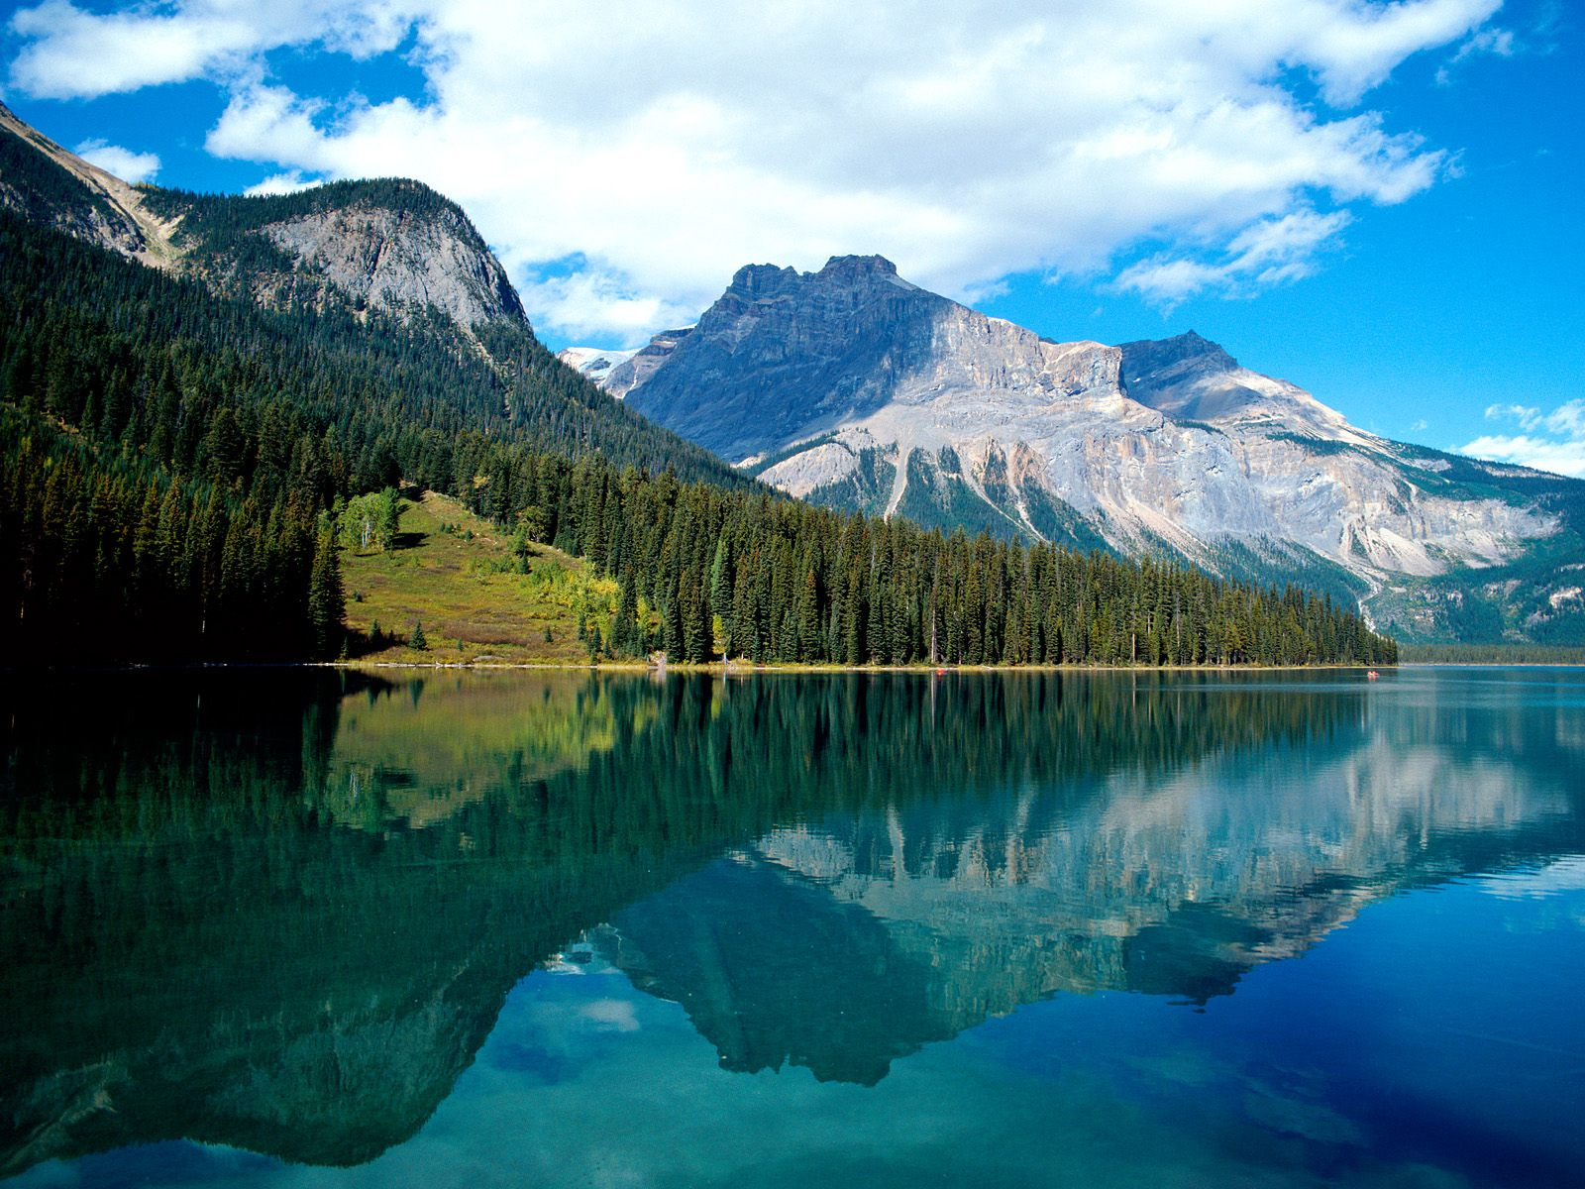

Provinces or Territories:

Landforms and Vegetation

Human Activities

**REGION 5: __________________________________**

(name)

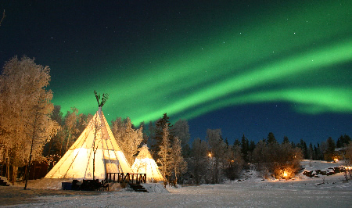

Provinces or Territories:

Landforms and Vegetation

Human Activities