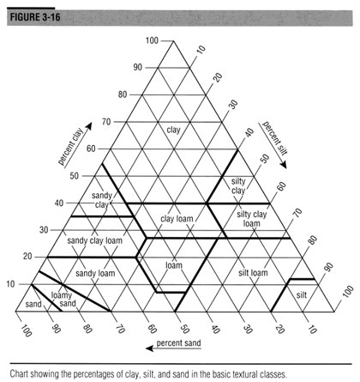
Soil Texture Chart Worksheet

Using the above diagram, answer the following – all number are in percentages (%’s)
- 30 sand, 30 clay, 40 silt__________  - 40 sand, 20 clay, 40 silt__________  - 70 sand, 10 clay, 20 silt __________  - 20 clay, 40 sand, 40 silt__________  - 10 silt, 60 sand 30 clay __________  - 90 silt, 10 sand __________  - 50 clay, 20 silt, 30 sand__________  - 60 sand, 10 clay, 30 silt__________  - 20 sand, 10 clay, 70 silt__________  - 40 clay, 50 sand, 10 silt__________ | For the soils types below, give the percentages  - Loam ______________________________  - Silty Clay____________________________  - Sandy Loam_________________________  - Clay________________________________  - Silty Clay Loam________________________  - Sandy Clay Loam______________________  - Clay Loam____________________________  - Sandy Loam___________________________
Using the text This Earth - Read p. 43 – 46. The Earth’s Four spheres.

Copy into your notes AND label FIG, 1.4.3 in the space above.
Summarise the following – what is it? How do it work?
Atmosphere

Geosphere

Hydrosphere

Biosphere

The Interaction Among the Spheres

Answer in your notes Q’s 1-2 on p. 44 and Q’s 1-2 on pg. 46 of This Earth

