Preston High School Geography Department
THE STORY OF EARTH
Part 1
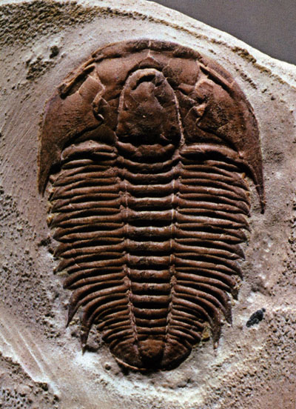
- In the beginning (5 million years ago –mya) Earth was 1 of _____ planets circling the sun.
- The newborn planet was a boiling ball of liquid rock at _______bya.
- The original moon was formed from a ring of red hot rubble and dust. It was only _________km away from earth instead of __________________ today.
- 3900 mya (3.9 bya) Earth is under attack from ____________ from the remnants of the solar system. These contain __________________, a vital ingredient for life on earth.
- As the meteors bombarded the earth for __________ , water collects on the newly formed solid ground of the earth’s surface.
- Every drop of water we drink today is ______________ of years old.
- At this point water covers much of the earth’s surface. Erupting __________________ create islands which will later joint to form the ______________________.
- The oceans now have become a giant _______________________ soup. From the combination of minerals left form meteor showers and sea water circulating through the crust, the earliest forms of ______________ emerged.
- At 3.5 bya the earth is primarily covered by a shallow___________________.
- ___________________________ (cyanobacteria) grow on the shallow sea floor and look like rocklike mounds. They are really living communities and turn sunlight into food, the first instance of ___________________________________
- In performing photosynthesis, stromatolites fill the oceans with _____________________.
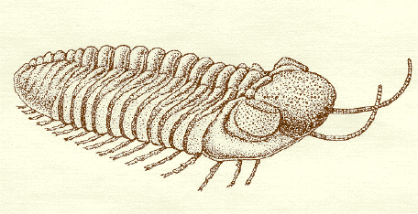
- Over the next ______ billion years, oxygen levels in the atmosphere rise and it is all due to stromaltolites which can still be seen today.
- Over billions of years we can see something is rearranging the islands. The earth’s crust has broken into vast _______________.
- Deeper still in the earth’s core, movement causes _________________ and _____________
forces on the plates. This causes them to move along with the oceans and islands.
- A new supercontinent is formed called _______________________________.
- 750 mya…. The earth seems to be ripping apart… Heat is causing the great super continent to be ripped in two and in doing so spawned a mass of ______________________.
- Following the absorption of massive amounts of ______________________________ into the the surface rocks the atmosphere is not able to retain heat and the earth cools forming a frozen ball of ice.
- After ‘snowball earth’ melts, the temperature heats up and is the perfect recipe for life. All the life on earth is in the _____________________.
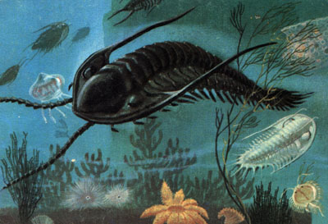
- At 650 my life now includes plants and animals and is known as the ____________________ explosion.

An example of life is the trilobite.

