The Agriculture Industry – Essential Learning #2 Assignment
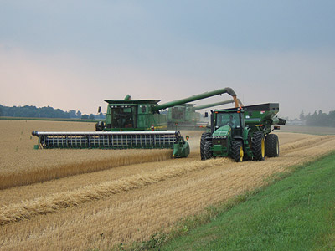
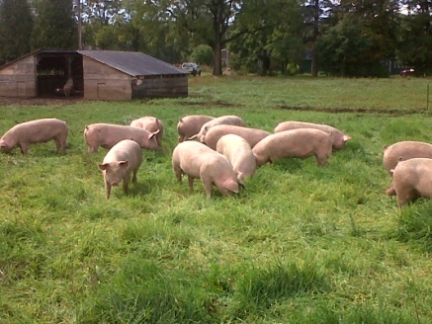
Intro: Throughout this unit, we have learned and discussed a wide array of agriculture topics. From laying hens and broilers, to quota, animal husbandry, crop production methods, GM seeds and pesticides - there are many topics or combinations to choose from

Goals:
For this assignment, you must provide evidence of learning for the following
- Appropriate terminology from the course work
- Animal husbandry systems
  - These can include barn systems(factory farming systems), manure handling and associated risks, gestation crates, outdoor hog production (Barrie”s Farm Visit)
- Chickens – laying hens and broilers and the supply management system (quota)
- GM crop production, tillage methods, pesticides and herbicides, collapse of the honey bee

Formats

- . Create your own farm (Individual or Partners)
Each person/partnership will be given a 100 acre plot of land in Southern, Ontario. To begin, each plot of land will have the following essentials.
- 1 farm house (where you live)
- 2 hills
- 1 stream
- Sandy loam soils (well drained and fertile =the best!)
- You have won the lottery and you have all the money you need to start whatever enterprise you want. What are you going to do?

Things to remember:
This is your sole business! You need to be able to make money from your farm or your family will go hungry. You may use the land anyway you want. You can build a chicken confinement, build a manure pit, make an orchard, have an on -farm store, grow GM corn, grow organic wheat, rotationally graze beef cows etc. You can use any combination of crops, animals and management styles – everything must be legal. Eg. You can’t raise 50 000 broilers, without stating that you had to purchase quota for the exact amount

For this activity, you will be required to complete 2 tasks

Task #1 – Map/Diagram – You will draw a map of your farm. Where are your buildings? Which crops are where? Where are your animals situated? Needs to be neat, coloured, attached legend or labeled – can be computer generated – You may develop a diorama if you choose

Task #2 – Explanation – Using detailed descriptions, you must justify your choices. Elements you need to be mindful of include
Cropping
- What crops are you going to grow? Why? Are they organic, conventional, GM?
- Erosion and Stream Health (Are you going to have constant ground cover? What tillage method will you use? In what ways are you going to prevent erosion? Is your farm going to use pesticides or Round-up Ready technology?
- Surrounding wildlife (Will your farm benefit the surrounding wildlife?
- Economics (Will your farm make money, if so, explain.)
- Energy Consumption (Is your farm tractor and fossil fuel dependent? Do you only keep animals over the spring, summer and fall on grass? )
Animal
- Are you going to keep animals? If so, which ones and how many?
- Why did you select these animals?
- Are you going to keep them in a barn? Are they going to be outside? Rotational grazing?
- Animal Health (predict how your animals react to the way they are housed?

For your explanations, the more detailed and in depth your thinking , the better. Your responses should be 2 pages minimum, double spaced.

2. Essay Writing (Individual)
For this task, you will write a persuasive essay. This essay will be 5 paragraphs including an introduction (including a thesis) three paragraphs, (point, proof, comment) and a conclusion. This must be researched using APA formatting for references and in text citations. Double spaced (1000 words approx.)

You must discuss your thesis with me before you begin.

Topics may include
GM Organic Farming Factory Farming
Colony Collapse of Bees Antibiotic Residues in Meats Corporate Farming Neonico tinoids Supply Management (Quota) Loss of Family Farms
Terminator Genes High Responders

