1. Who is the governing body that is supposed to be the determinant of “what makes a country a country?

**UNITED NATIONS**

1. Why is this determinant of ‘statehood’ not a universally recognized list?

**BECAUSE MANY MEMBER STATES OF THE U.N. DO NOT RECOGNIZE EACH OTHER. For example: North Korea and South Korea, 30 countries don’t recognize Israel**

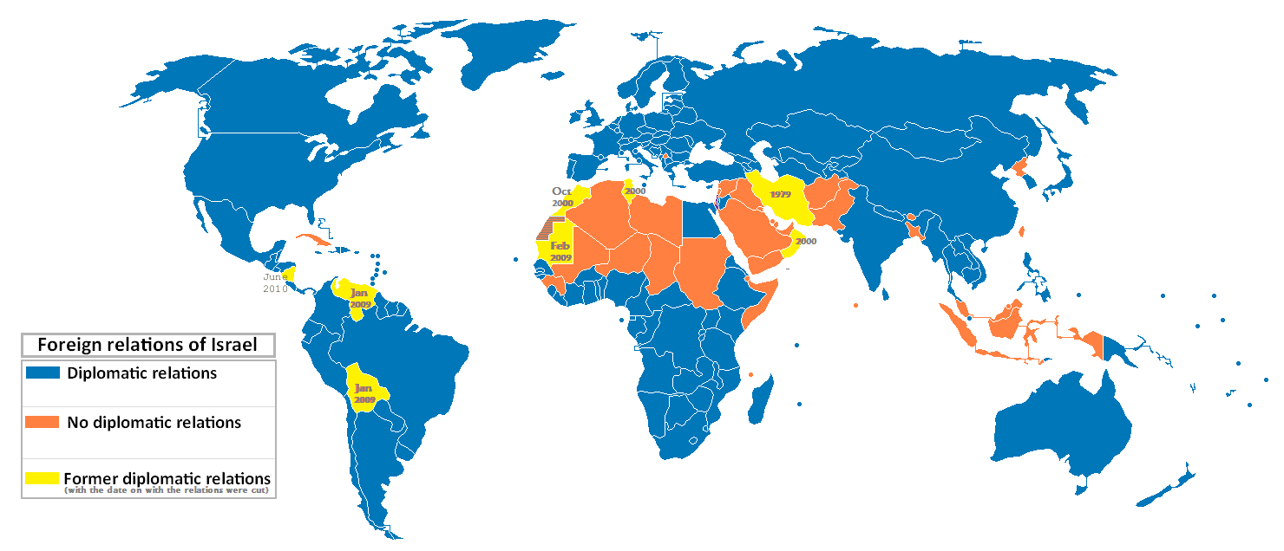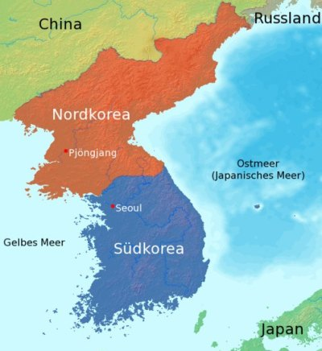

1. What is the problem of accepting a new member into the ‘club’ considered poisonously controversial?’ Can you identify an example close to home that would be a good example of new membership worries and state why?

**BECAUSE IF A MEMBER STATE HAS A ‘BREAKAWAY’ REGION, AND WANTS IT’S OWN SOVEREIGNTY, AND IT IS RECOGNIZED AS A NATION BY THE U.N. THEN IT ENCOURAGES THE SOVEREIGNTY MOVEMENTS WITHIN OTHER MEMBER COUNTRIES.**

**For example: Quebec – Canada, Catalonia – Spain, Kurds – Iraq and Turkey and on Thursday Scotland votes to breakaway from the United Kingdom**

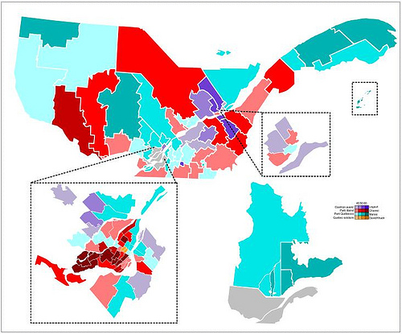

1. Outline the four criteria for the status of nationhood. For each state the what the criteria means in real terms and outline some problems with each.
2. **Permanent Population**

Modern Populations are not so permanent – they are mobile. Ie. Lebanon’s diaspora is 3 to 4 x greater than the population in Lebanon. And many of these expatriates have the right to vote.

Same as Greece, Ireland….

1. **Government**. Poland – repeatedly invaded so government was in exile overseas for 50 years still maintaining functions of a government
2. **Defined boundaries**
   1. India and Pakistan in conflict over Kashmir
   2. Indeed even Canada and the United States have boundary issues in 5 areas.

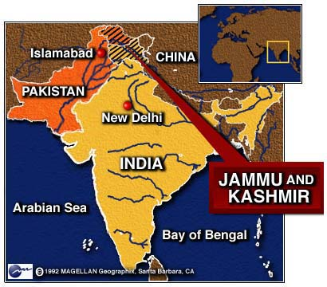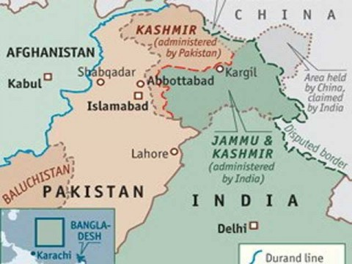

1. **Capacity to enter into relations with other states**
   1. Taiwan and China. Is Taiwan part of China? China thinks so but Taiwan does not.
   2. Somalia – anarchy. There is no government, just regional warlords.